CMTA Blog Template

BE A PART OF THE CMTA BLOG

Instructions for CMTA and Divergent Workshop Presenters

First, thank you for your willingness to present your material at this year’s Christian Ministries Training Association (CMTA) Convention, and congratulations on being chosen as a presenter/faculty of this year’s event!

You and CMTA share a conviction about the importance of helping train Christians for ministry (Ephesians 4:11-13). One of the main ways we do this is by holding an annual convention where, together, we equip church leaders through the inspirational and informational teaching of people like you. Thank you!

Now, CMTA is offering an additional ministry. It is one meant to equip God’s people throughout the year. CMTA Blog (now in the process of being built)

Here is the template, how you can make your content:

Replace this Line with the Title of Your Session

Replace this Line with Your First and Last Name

- Optional: You can insert (or attach) an interesting image OR we can locate one for you.

Image SEQ Image \* ARABIC 1: Scene from "Freezing Teens" (Note: Go on the Internet and find four different pictures from scenes in the movie to use as images for your blog posts)
Replace this Line with a Brief Interesting Introductory Statement About Your Topic

Delete this content in the paragraph provided and replace it with your content in multiple short paragraphs. Feel free to use bold, italics, and underlining when it can help you communicate your ideas. You can summarize some of your main ideas or insights in bullet points, bolded headings, or any way you like. See the blog sample on the next page for ideas. This section will be 300-600 words.

Insights for Christian Ministry

- Replace these bullet points with your own insights.
- Include specific insights on how to apply your ideas to real-life ministry

Bio

Replace this line with your First and Last Name
Replace this line with your Title, Role, or Something About You or Your Ministry your link and social media page.

SAMPLE BLOG POST

(Yours will look different. This is just to give you an idea of how to write a blog post)

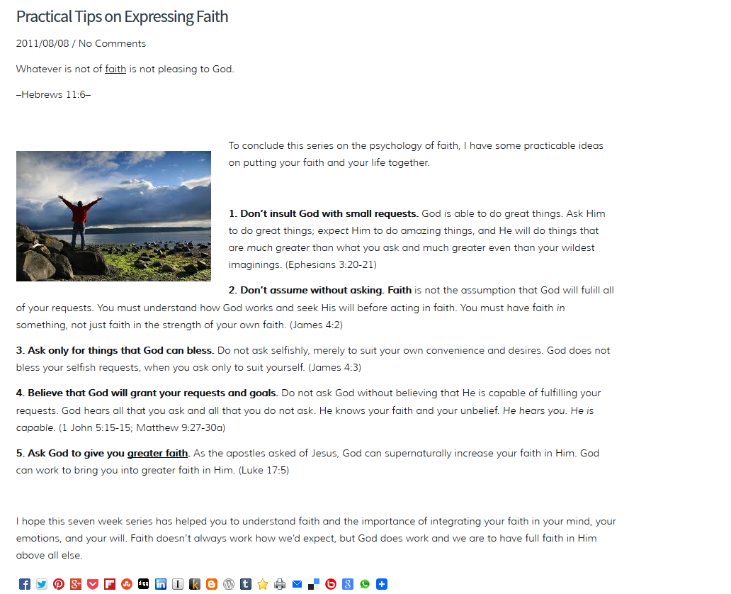

Our goal is mutual ministry growth to glorify our Lord!

We will be moving toward to be a complementing competitor to http://www.churchleaders.com/

Be blessed! The CMTA Board and Team!
Phil1:6

